Document Reference | COP201508251
Version | 1.2
Publication Date | 2015-08-25
Status | Published
Security Tag | Public
Document Author | Gareth Thomas
Document Owner | Gareth Thomas

10 ACT LTD T/A TRACKBACK

Code of Practice on Complaint Handling and Dispute Resolution

10 ACT LTD T/A TRACKBACK is an independent company that delivers communications services to business customers. While we may not provide all the component parts of our services ourselves, we do take responsibility for the services delivered to you. So we will liaise with our suppliers to ensure that any problems with their services are resolved promptly.

We make every effort to ensure that our customers are happy with the level of service, and the products and service they receive from us. However, despite our best efforts, things can go wrong. We take customer complaints very seriously and aim to resolve them quickly and efficiently.

If you have a complaint about any part of our service, please contact our Customer Service Team using one of the following
By phone: 08081 280080
By email: support@TrackBack.net
By letter: Customer Support, TrackBack, 8 Waldegrave Road, Teddington, Middlesex, TW11 8HT

If you telephone, our advisors will ask you about your complaint and seek to resolve the problem while you are on the line. During any discussions we will protect the privacy of the information that we hold on you. To do this we may have to ask you questions to confirm that we are speaking to the right person.

If you make your complaint by email or in writing, we will acknowledge receipt, advise how and when we will next respond and provide you with a contact point for checking progress on the resolution of your complaint.

We will try to resolve your complaint quickly and efficiently, and to keep you informed at all times. We normally aim to resolve complaints within 10 working days but, depending on the nature of the complaint, this is not always possible. However, If you are not happy with progress in resolving your complaint you can ask the person to whom you are speaking to escalate the matter to their manager, and ultimately to the Managing Director. If we cannot resolve the problem, we will write to you to say so.

If it has been more than 8 weeks from the date you first contacted us to complain or you have received a letter from us saying that your complaint has reached “deadlock”, then you may ask for help from:

(CISAS/ The Ombudsman Services) is an independent organisation which is approved by Ofcom to provide an alternative dispute resolution (ADR) service. Ofcom-approved ADR services sort out disputes between communications providers and their consumer and small business customers. Their job is to investigate complaints fairly by listening to both sides of the story. They look at the facts given to them before recommending any action that may be needed to put things right.

Alternatively, if at any time you are not satisfied with the progress of your complaint you can ask us to agree an early referral to ADR (i.e. that we issue a deadlock letter). However, we may decline to do so if we do believe we will shortly resolve your complaint and are taking active steps to do so.

Useful addresses

Cisas– 24 Angel Gate, City Road, London EC1V 2PT, Tel: 0845 1308 170 or 0207 520 3827
e-mail: info@cisas.org.uk Website: www.cisas.org.uk

Ofcom - Riverside House, 2a Southwark Bridge Road, London SE1 9HA. Tel: 020 7981 3040 or 0300 123 3333 email: contact@ofcom.org.uk Website: www.ofcom.org.uk

PhonepayPlus (formerly Icstis)- Clove Building, 4 Maguire Street, London, SE1 2NQ. Tel: 0800 500 212 or 020 7940 7474 Website: www.phonepayplus.org.uk email info@phonepayplus.org.uk
Telephone Preference Service - DMA House, 70 Margaret Street, London W1W 8SS Tel: 0845 070 0707 Website: www.tpsonline.org.uk
Federation of Communication Services (FCS) - Burnhill Business Centre, Provident House, Burrell Row, Beckenham, Kent BR3 1AT. Tel: 020 8249 6363 email: fcs@fcs.org.uk Website: www.fcs.org.uk

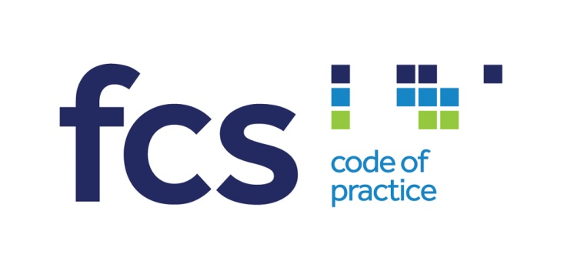

This code has been licensed by The Federation of Communication Services Limited 2012
Licence number C-002848

